**Homework problems (lectures 2-7)**

**Lecture 2 (ARM Intro – Not tested)**

1. What does the following code do?

CMP R0, #9; ITE GT; ADDGT R1, R0, #65; ADDLE R1, R0, #48;

**Lecture 4 (ADC I)**

1. According to Shannon-Nyquist theorem, we must sample at more than twice the highest frequency to reproduce the original waveform. Why not sampling at twice the highest frequency?
2. What is the condition called that refers to the distortion caused by sampling below the Nyquist rate?
3. What does **1/Ts** represent and what units does it have?
4. If signal averaging is used for sampling an input signal of with a highest frequency f max, what is the relationship between M , f max and the sampling rate f s to ensure that the signal averaging operation does not introduce significant aliasing?

**Lecture 5 (ADC II)**

1. Understand the example code ADCdemo1.c with help of the following documents

* Using the Stellaris Microcontroller Analog-to-Digital Converter (ADC).pdf
* TivaWare Peripheral Driver Library Users Manual.pdf

1. What type of ADC is used on the Tiva C-Series Launchpad?
2. What common instrument uses a dual-slope integrating ADC?
3. How many analog channels are supported by the Tiva C-Series Launchpad ADC?
4. What is the range of quantisation error in volts for an 8-bit quantiser with an input range 0 – 3 V?
5. If the maximum signal frequency is 500 Hz and 12-bit quantization is being performed with signal averaging over 15 consecutive samples, what is the minimum sampling rate?
6. A 3-bit uniform quantisation with **Vmax** = 1 V and **Vmin** = 0 V, quantization step **Δ** = 1/8 and Analogue input = 0.425 V.

Find the (3-bit) **quantisation result** in binary.

**Lecture 6 (Noise)**

1. A primary source of noise in resistors is due to thermal (Johnson) noise

* What is the noise RMS voltage of a 1 MΩ resistor at 300° K over a 100 kHz bandwidth?
* What is the noise RMS voltage of a 1 MΩ resistor in parallel with a 1 kΩ resistor at 300° K over a 100 kHz bandwidth?

1. In the example with SNR = 20 dB shown on slide 12, the average power of the signal is 0.9 W (ignoring the DC offset). What is the average power of the noise?
2. In slide 13, explain why the noise amplitude on the right (obtained via signal averaging with M=32) is significantly less than that on the left (obtained via signal averaging with M=16).
3. For a sinewave with amplitude A and frequency f Hz, What is the maximum error magnitude is ∆𝑉 = 2𝜋𝑓𝐴∆𝑡?
4. 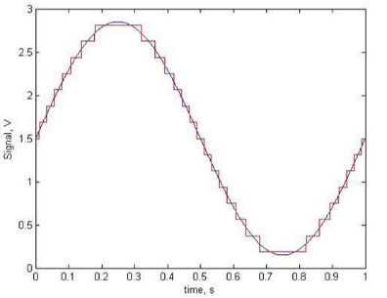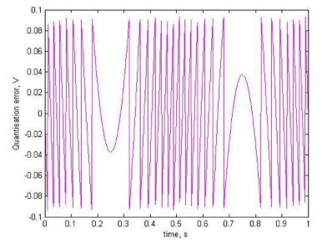A 4-bit uniform quantization with 16 discrete values.

* Find the Quantization step Δ.
* Find the Random error with maximum magnitude.

**Lecture 7 (Interrupt Processing I)**

1. Can the ADCdemo1.c program achieve a comparable performance without using interrupts? If so, how? If not, why not?
2. By looking within the microprocessor datasheet TM4C123GH6PM Data Sheet.pdf, find out how many sorts of interrupts can be generated by the ADC and Timer modules. List all the types (assuming all timers are the same and ADC channels are the same).
3. In general, how can a compiler decide which of the registers need to have their contents saved as part of the context?